Jackson Warren

Jeremy Bergen

CSCI 370

12/13/21

Lab 13

Section 1:

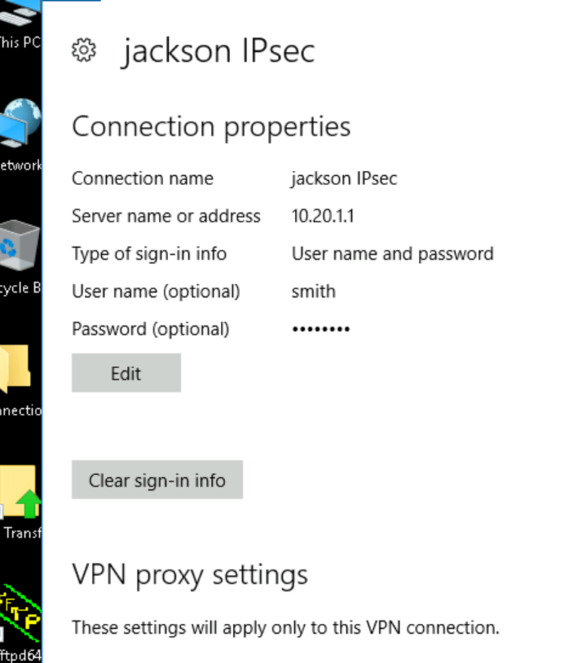

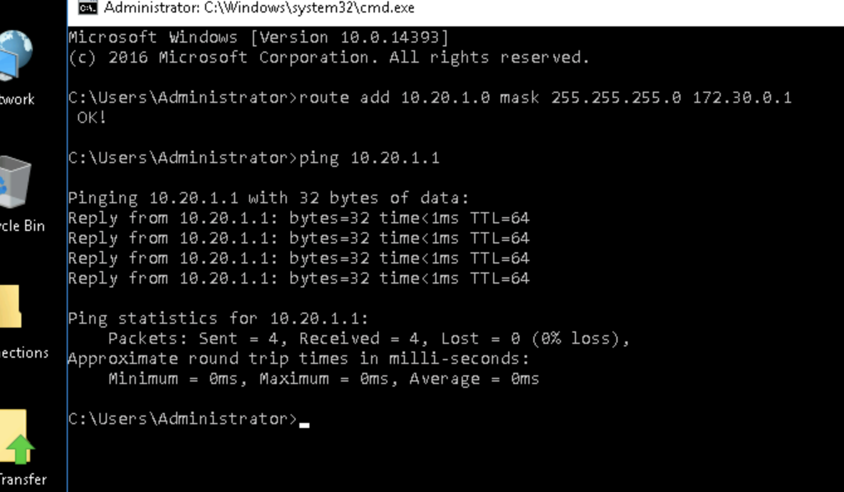

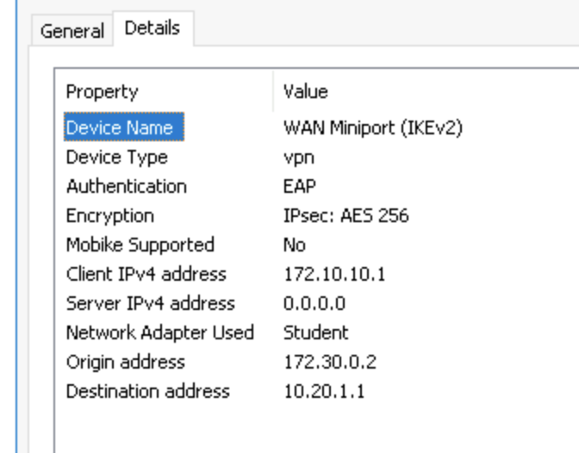

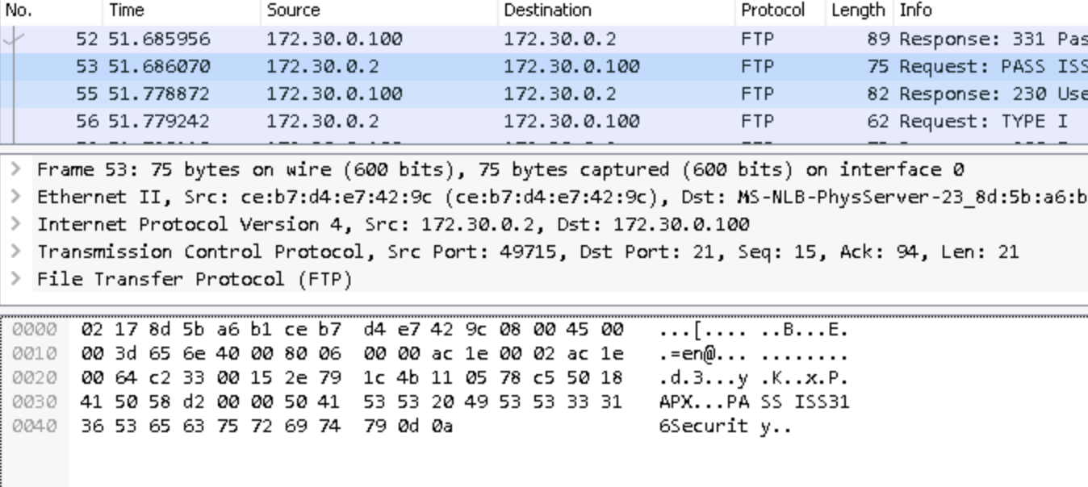

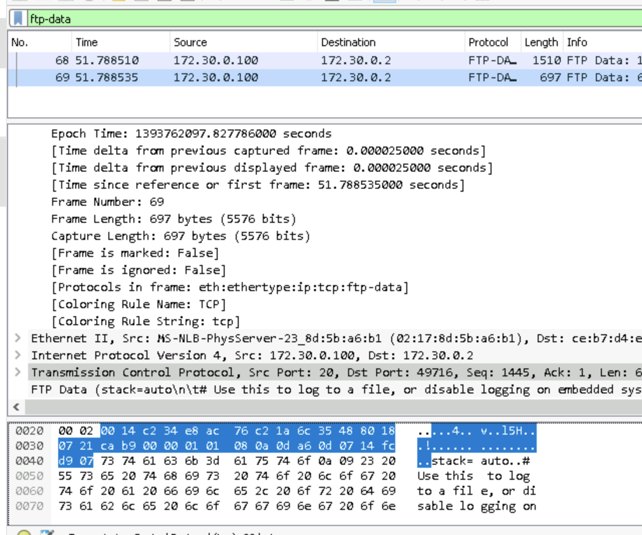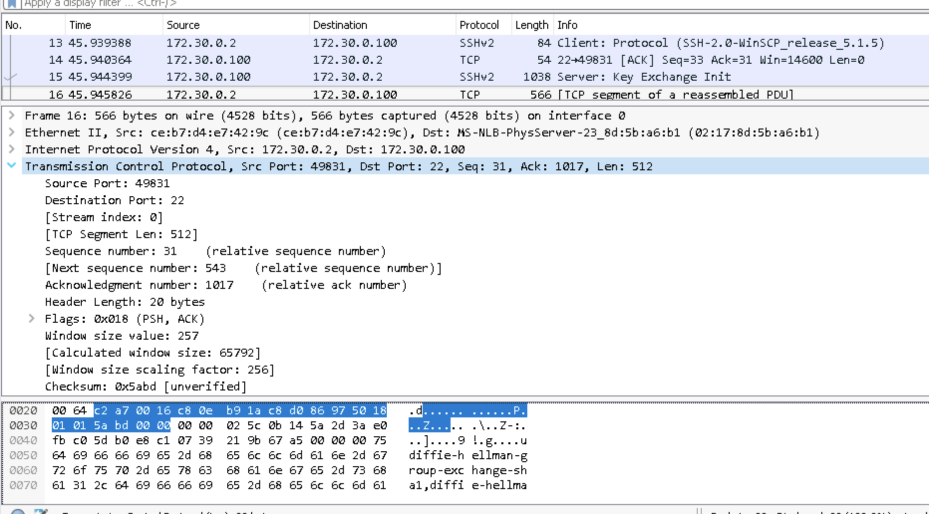

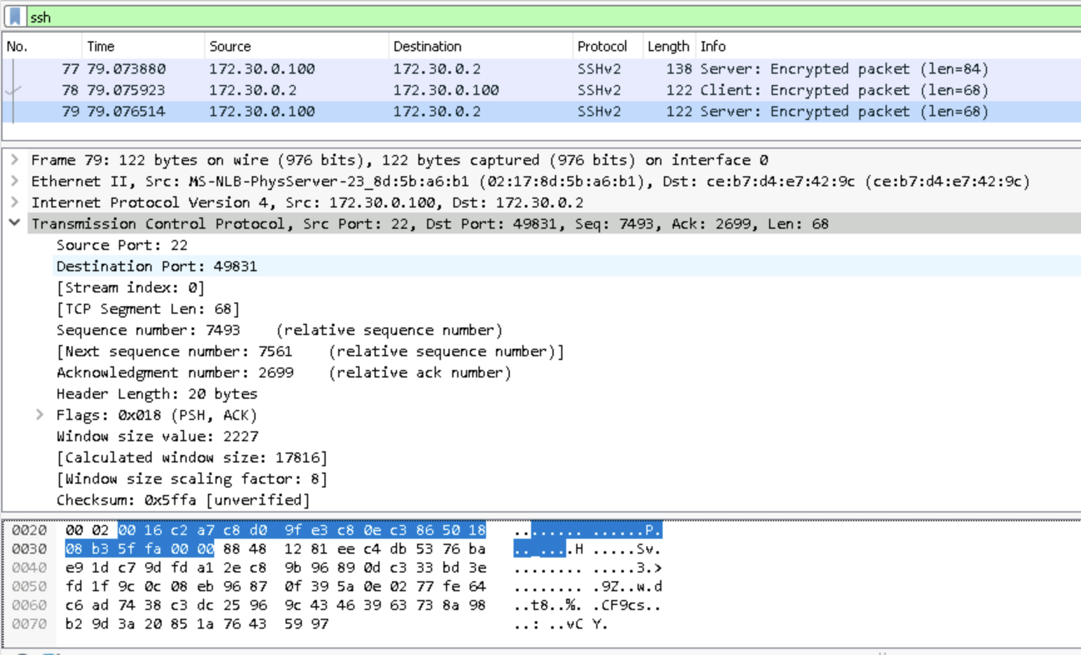

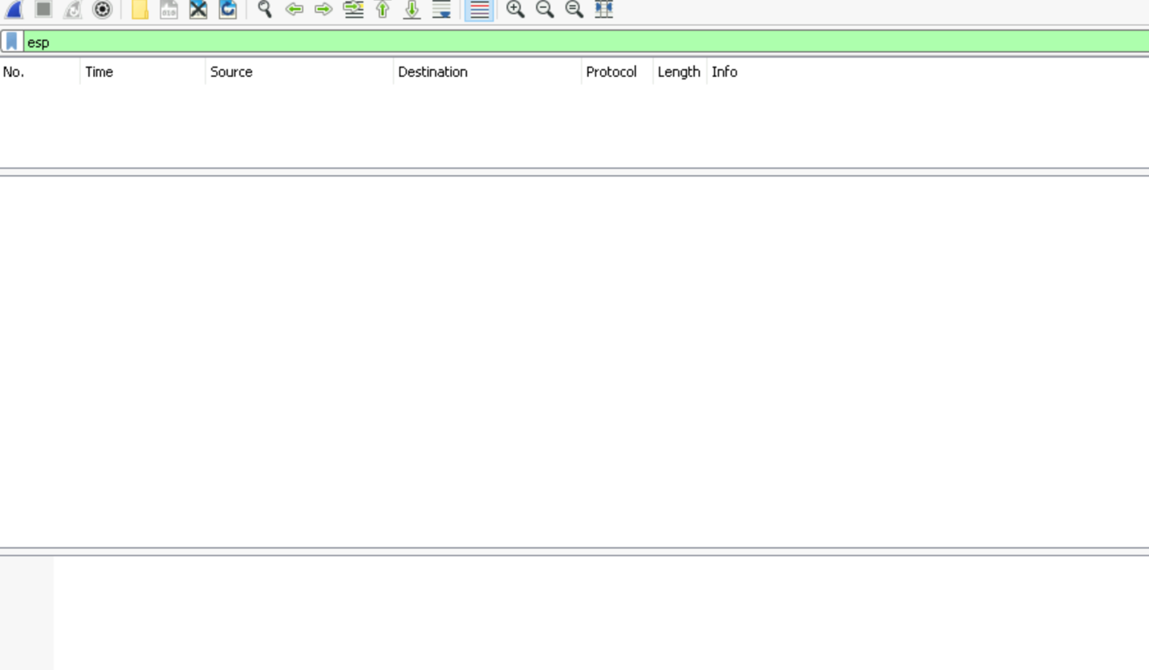

Not getting any esp traffic.

Section 2:

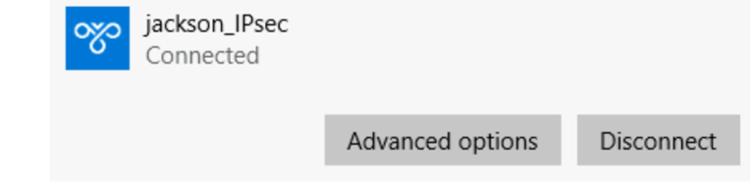

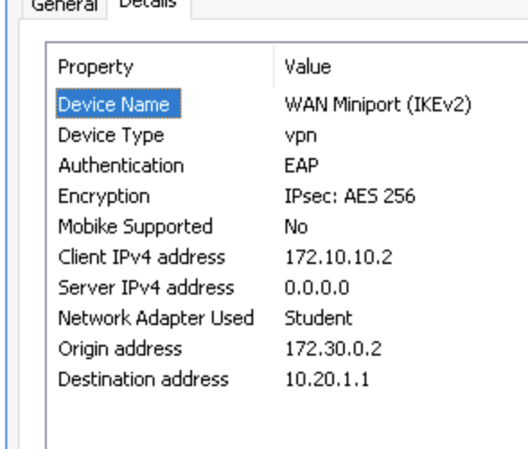

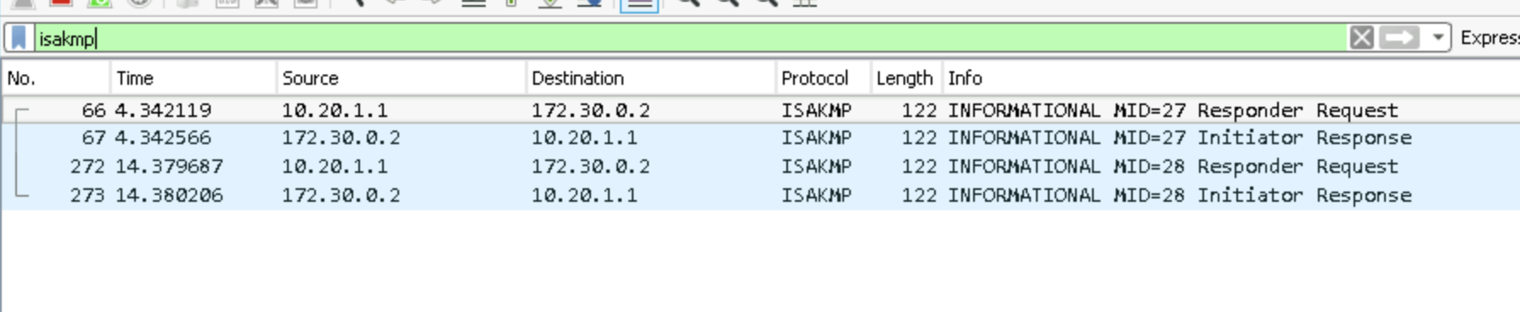

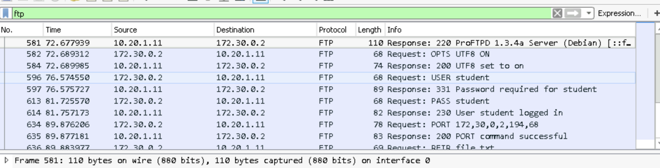

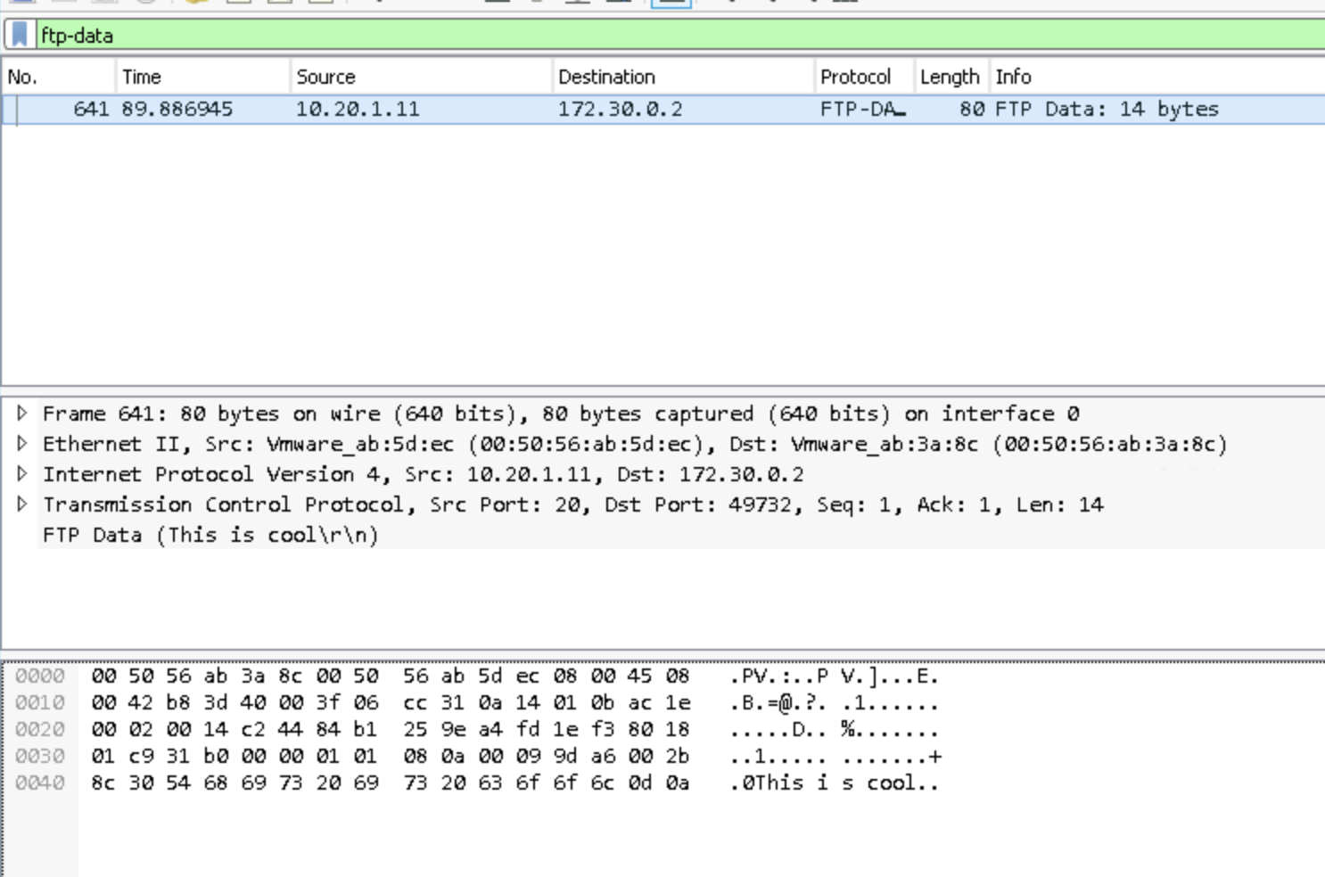

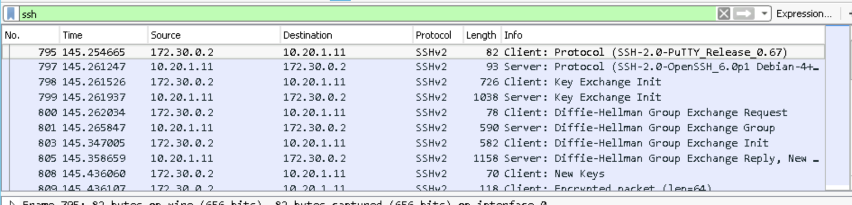

Frame 808 is the new key frame.

Section 3:

Part 1: Lots of benefits from VPN. More secure, bypass region locks, pass firewall conflicts, and more.

Part 2: 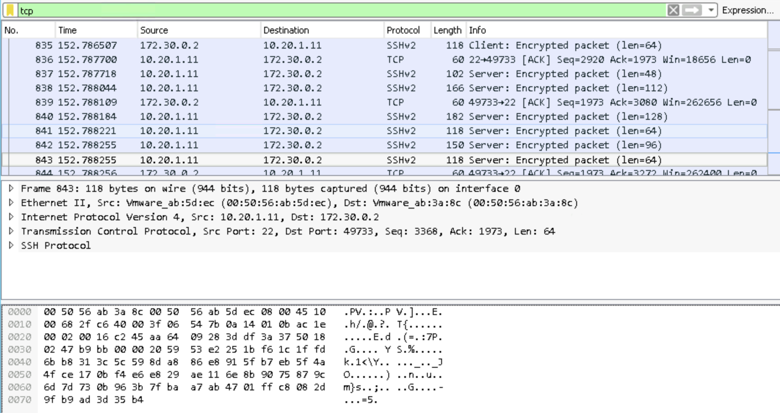

We see a lot of requests and responses. Several syncing pages I believe. Transferring messages and confirmations. Communicating the exit of the sessions. The quite a few encrypted packets receive and response communication from both client and server.

Part 3: Ok, so I cannot figure this out for the life of me. I can’t find a way to put the new quote text file in a location I can grab it using that connection. But! I have already done this and know how to do it. So, as me and my troubles with wireshark and this continue, here is the text you would’ve seen in my file if it had all worked: